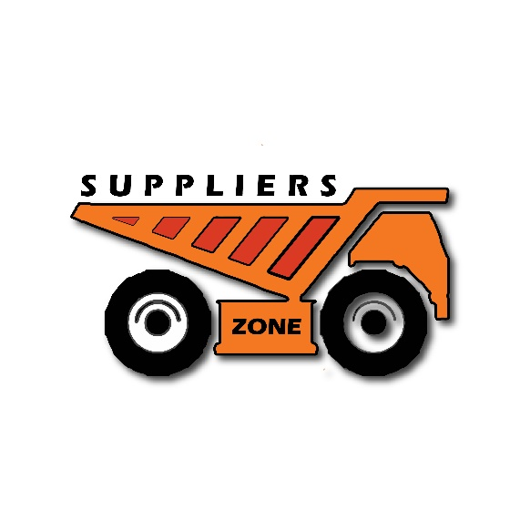

**Company Profile**

**SUPPLIER’S ZONE**

**Head Office:**

Shahittiyika Polly,4700 ,Cox’s Bazar.

Contact Number: 01580420825

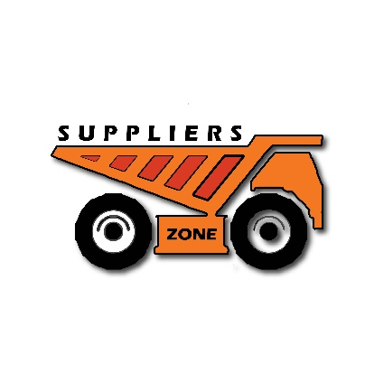

**SUPPLIER’S ZONE**

Ref: Date:

**Who we are:** Supplier’s Zone is one of the oldest supplier of Sand, Stone , Iron

etc. We have been in this market for the last five years as a whole

seller, supplier, distributor and service provider with sincerity, honesty, and dedication.

**Our Vision:** To make our company innovative, modern and sustainable through

hard work.

**Mission:** We would like to achieve a long term relationship with our valued customers,

clients and stakeholders. We care for encouraging and empowering rural people to be

a part of this hardware industry and modernizing itself as a social business with

development and progress.

**Environmental Issue:** Most of our Supplying items and trading products are

environment friendly.

**Professionalism:** We have a team of regular staff consisting of fifty members

and around two hundred casual workers. We are committed to deliver our customer

needs on time and we always welcome our valued customers' feedback.

**Supplier’s Zone**

Trade License No: 00638

e-TIN No:

BIN Number:

**Bank details**:

Bank Name: Brac Bank Ltd,

Account Name: Supplier’s Zone

Account Number: 1104204780282001

SWIFT :

CDA Avenue Branch , Chattogram.



**SUPPLIER’S ZONE**

Ref: Date:

**Qualities:**

* Courage and readiness to communicate on behalf of client in crisis .
* Strong technological background
* Ready to provide service to the client at any emergency situation.
* Unique and creative solution to meet the client expectation .

**Our customers and clients**:

As a trustworthy vendor we have achieved some fame in the market. Some of them are:

* UNHCR
* Unicef
* WFP
* IOM
* Brac
* Save the Children
* TDH
* RHD
* Rana Builders
* Abdul Monem Construction
* H.A Enterprise
* Niro Enterprise
* M. Madina Enterprise
* Nihad maritime and construction.
* Javed Enterprise
* Adnan Enterprise
* Shahin Traders

**Services:**

* Construction material supply
* Unloading facility
* Sand / stone storage facility
* Transportation Facilities of Construction material
* Filling Sand support
* Agriculture item supply



**SUPPLIER’S ZONE**

Ref: Date:

**Civil Construction:**

* Scheduling and monitoring the project
* Establishing and monitoring quality
* Setting project goals
* Project close-out and warranty

**Unloading Facility:** the facility is located in Majher Ghat, Tekpara, Cox’sbazar . We have equipped the facility with state-of-the -art machineries to ensure quality services .we are specialized for unloading and storing sand/stone vessel .

We are equipped with cctv surveillance to ensure maximum security. .we also provide transportation facility for our respective clients.

**List Of Equipment:**

* Drum truck
* Excavator
* Long boom Excavator
* Dredger
* Bulk Head
* Generator

**Contact us :**

Location : Shahittiyika Polly,4700 Cox’s bazar.

Phone - +88 01580420825

Email – [supplierszone21@gmail.com](mailto:supplierszone21@gmail.com)



**SUPPLIER’S ZONE**

Ref: Date:

**Our Products**

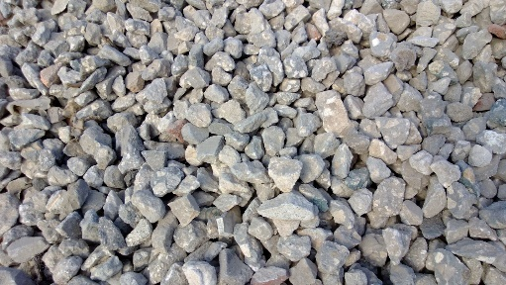 

**Stone Sands**

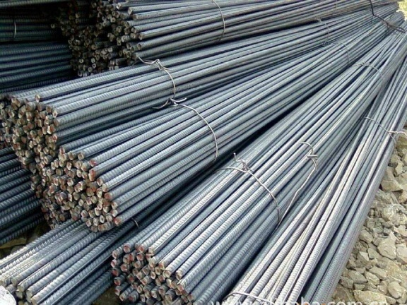 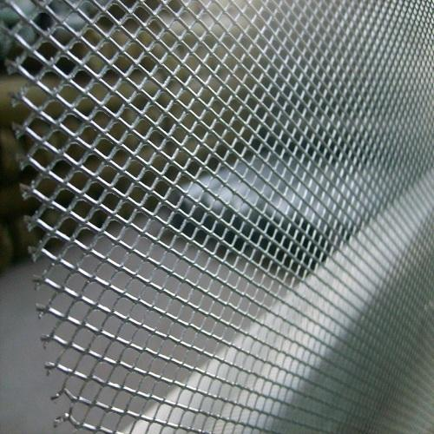

**Iron Rod Iron Net**



**SUPPLIER’S ZONE**

Ref: Date:

 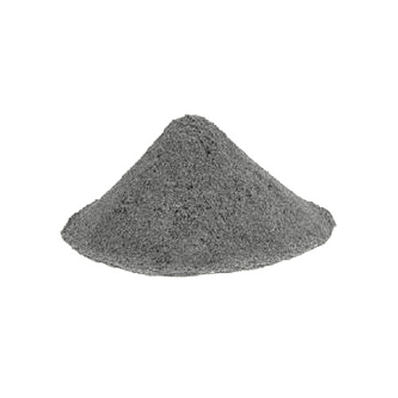

**Bricks Cement**